## 3rd Software Engineering Homework

### Unit Tests

##### ImageSplit class test

@ParameterizedTest  
@ValueSource(ints = {3,6,9})  
//Custom picture segmentation  
public void imageSplitTest(int i) throws IOException {  
 Image image;  
 new ImageSplit("C:\\Users\\84181\\Desktop\\test" +  
 "\\imageSplit\\图片\\" +i+".jpg",i);  
 for(int j=0;j<ImageSplit.*imageIcon*.length;j++){  
 image = ImageSplit.*imageIcon*[j].getImage();  
 ImageIO.*write*((BufferedImage) image, "jpg",  
 new File("C:\\Users\\84181\\Desktop\\test" +  
 "\\imageSplit\\生成\\"+i+"\\"+"_"+j+".jpg"));  
 }  
}

**Description：**

The imageSplit function in ImageSplit Class can split the image file with a custom path into i*i parts(i is a parameter),then save them in an array.

**Test：**

Input three pictures,which are divided into 9,36,81 pieces,and then force the type conversion of the segmented pictures and store in the corresponding folder.

**Result：**

Incoming picture：

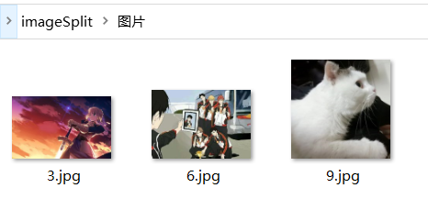

Output：（The color is different because of cast）

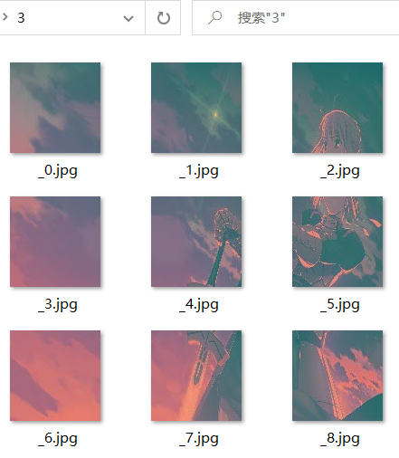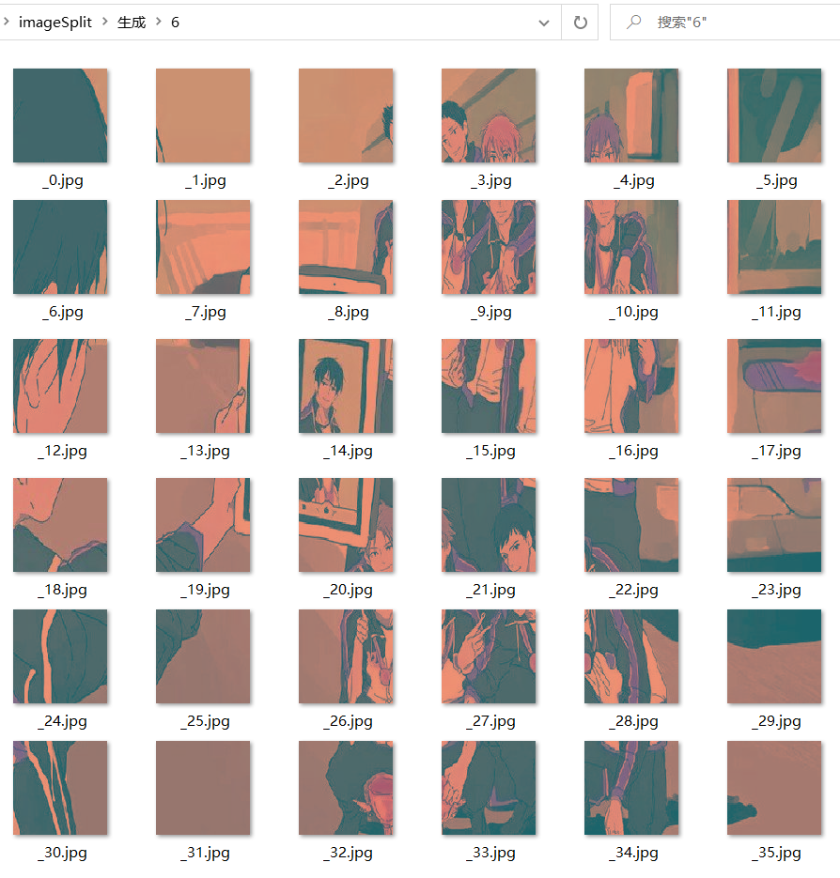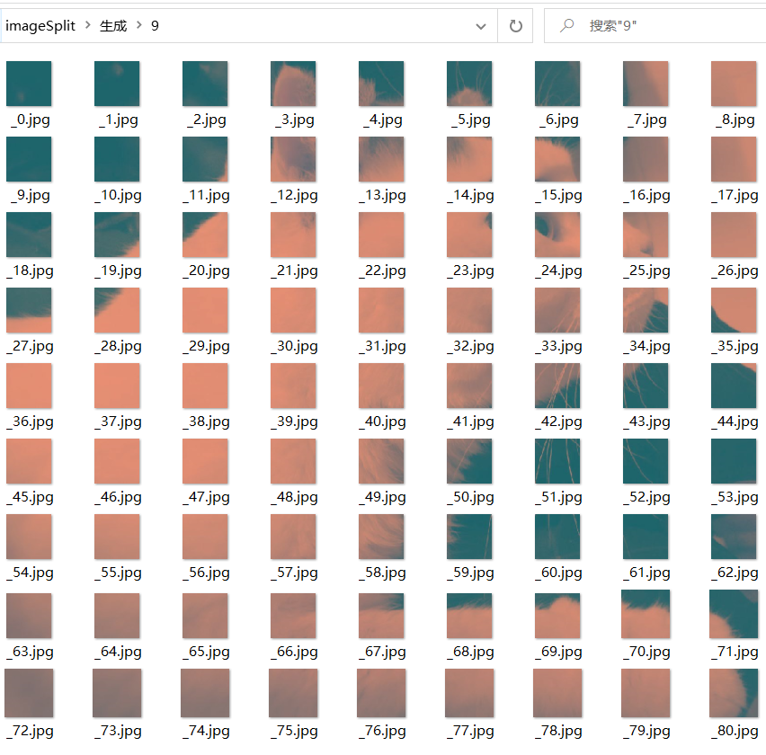

##### （2）Random sort function of pictures in NewPing_Tu class test

@RepeatedTest(100)

//check if the conditional sort results of the 4*4 pattern are correct.(100 times)  
public void newPing_tuTest(){  
 int a[] ;  
 int b=0;  
 new ImageSplit("C:\\Users\\84181\\Desktop\\test\\newPing_tu\\1.jpg",4);  
 NewPing_Tu ping_tu = new NewPing_Tu(16);  
 a = ping_tu.arr;  
 for(int i = 0;i < 15;i++)  
 for(int j = i + 1;j < 15;j++){  
 if(a[i] > a[j]){  
 b++;  
 }  
 }  
 *assertEquals*(0,b%2);  
}

**Description：**

Not every arrangement in Woods Slider has a result.Woods Slider has a correct result when the number of inversions in the sequence is even.The arrangement of images is checked in NewPing_Tu class until the conditions are met.

**Test：**

The final random array is detected to calculate whether its inverse ordinal number is even.

**Result：**

Tested 100 times, the results are all correct, that is, the reverse order numbers of the arrangement are even numbers.

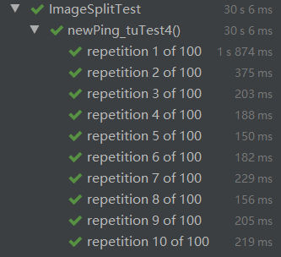

##### Ping_Tu class test

@ParameterizedTest  
@ValueSource(ints = {3,6,9})  
//Default picture  
public void morenPingTuTest(int i) throws IOException {  
 new Ping_Tu(i*i);  
 Image image;  
 for(int j=0;j<ImageSplit.*imageIcon*.length;j++){  
 image = ImageSplit.*imageIcon*[j].getImage();  
 ImageIO.*write*((RenderedImage) image, "jpg",  
 new File("C:\\Users\\84181\\Desktop\\test" +  
 "\\默认ping_tu\\"+i+"\\"+"_"+j+".jpg"));  
 }  
}

**Description：**

In Pint_Tu class, pass in the parameter i to divide the picture of the default path into i parts ,then save them in an array.

**Test：**

Pass in the parameters 9, 36 and 81 respectively, and then save the segmented images to the specified path.

**Result：**

Default picture：



Output pictures：

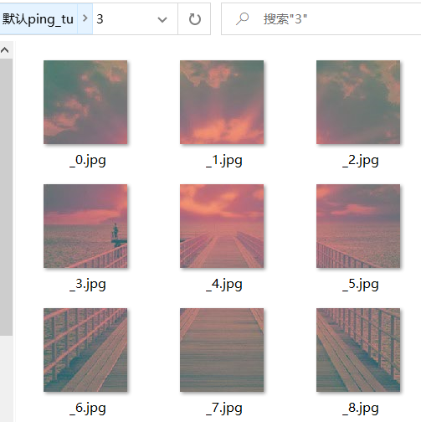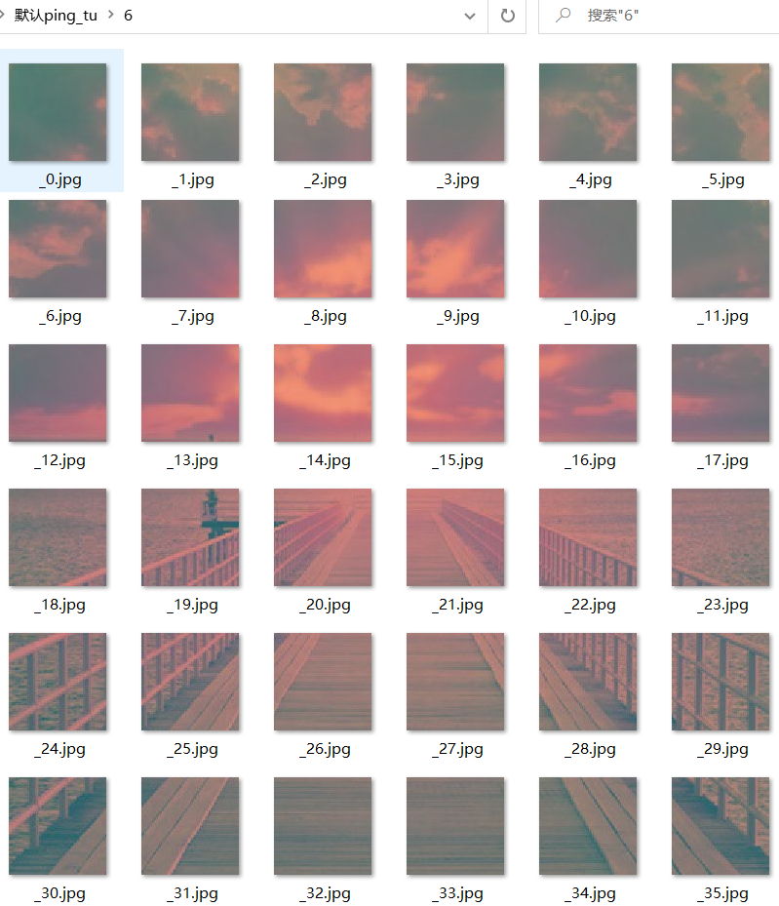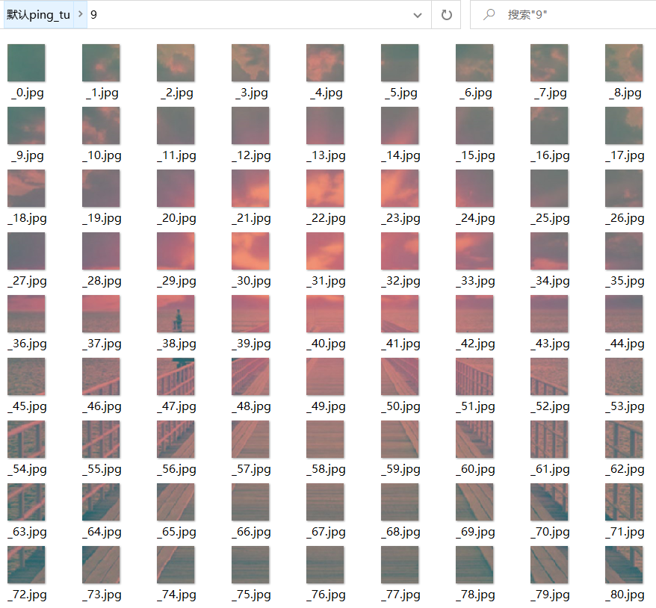

### Feature Tests

##### Play games with default pictures

Run the program and select "3 * 3" or "4 * 4" or "5 * 5" or "6 * 6" mode to play the game (select 4 * 4 here);

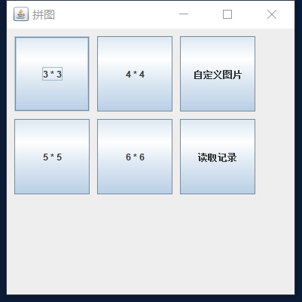

When the game starts, there is a timer (in seconds) on the right side of the window to record the game time；

Click the "重新开始" button to start the game again, and the timer starts from 0；

Click the picture next to the blank picture, the position of the picture and the blank picture will be swapped until the picture is restored；

Complete the puzzle, the game is over, refresh the record, display the refresh record dialog box, take 227 seconds；

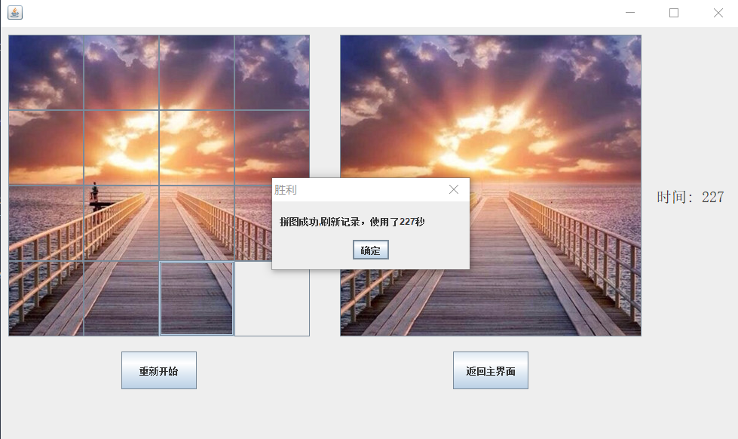

Click the "确认" button to restart the game, pictures switching order and reset the timer;

Continue the game, complete the jigsaw puzzle, there is no record refresh, the success dialog box is displayed, it takes 417 seconds。

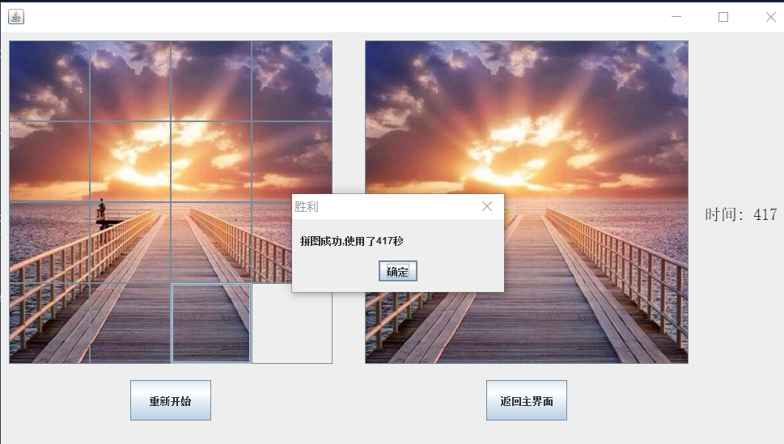

Click the "确认" button to restart the game. Click "返回主界面" to return to the main interface of the game;

Close the window.

##### Play games with custom pictures

Run the program and click the "自定义图片" button;；

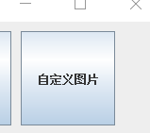

Select the file and try to select the .TXT file. A new file selection box will pop up again；

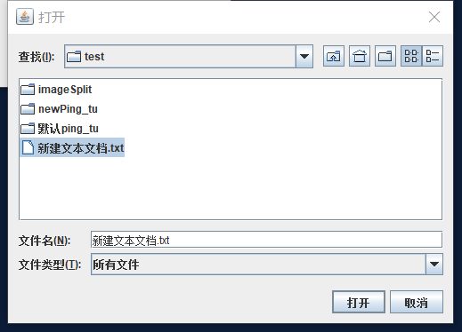

Select ". JPG" file to pop up the game mode selection box；

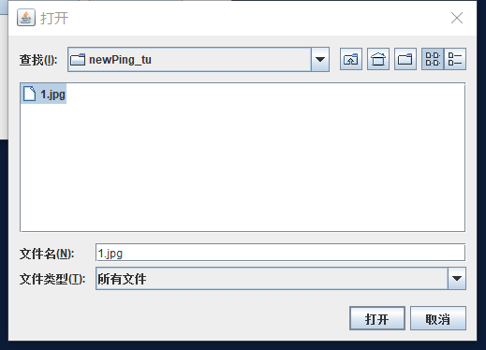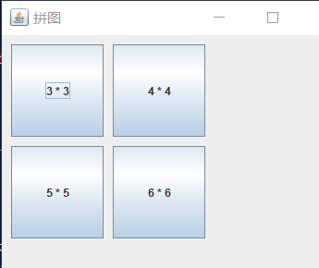

Select "3 * 3" or "4 * 4" or "5 * 5" or "6 * 6" mode to start the game (choose 4 * 4 here)；

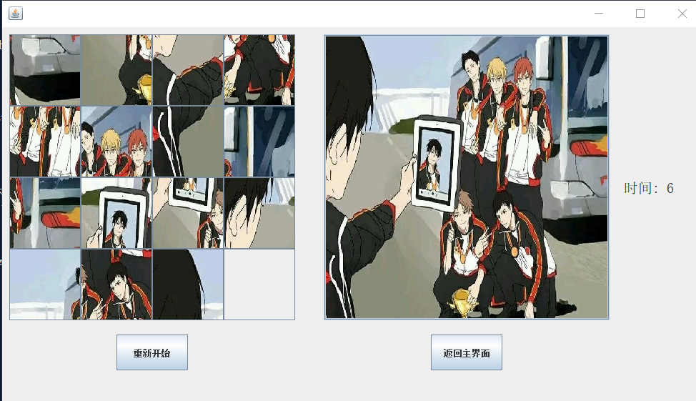

Select "重新开始" button, the pictures switching order, and the timer is reset；

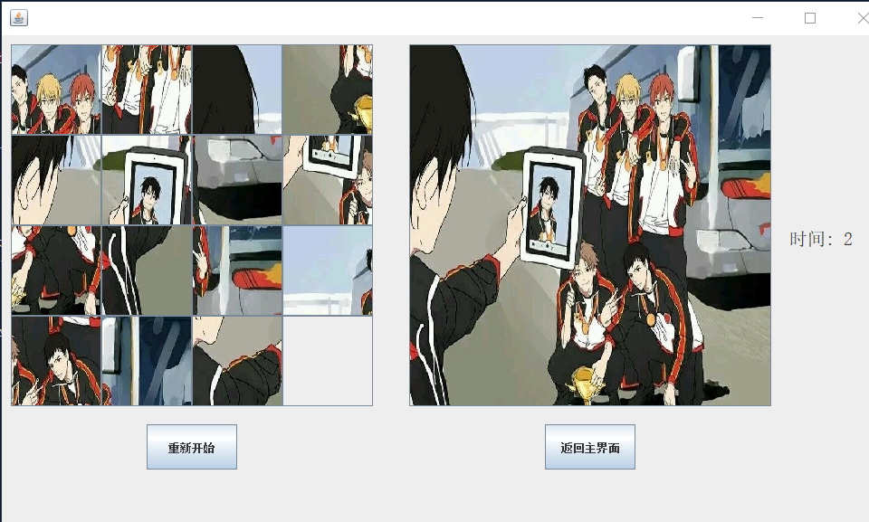

Play the game, after the end of the game, refresh the record, take 182 seconds；

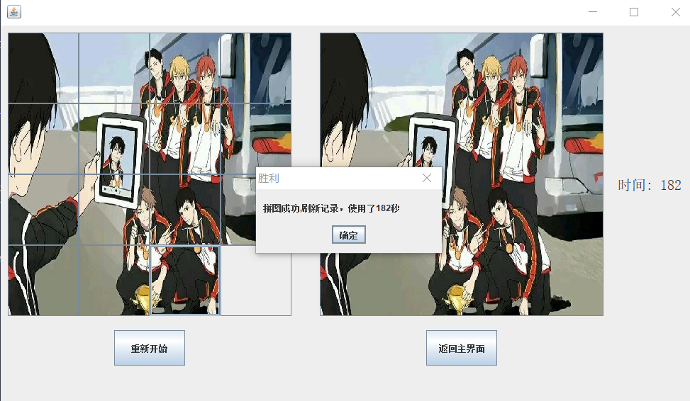

Select“返回主界面”button，Back to the initial window of the program；

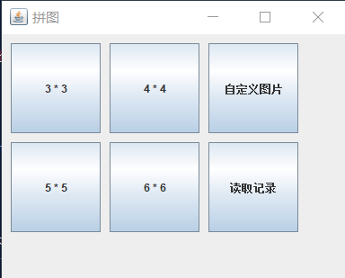

Close the window.

##### Function of Reading Records

Run the program and click the "读取记录" button to display the existing records；

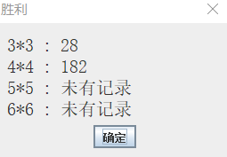

Play the "4*4" mode game, refresh the record, it took 108 seconds；

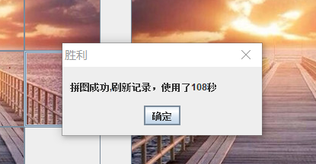

Click "读取记录" again；

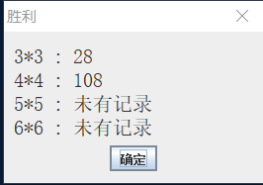

Play the "5*5" mode game, refresh the record, in 587 seconds.

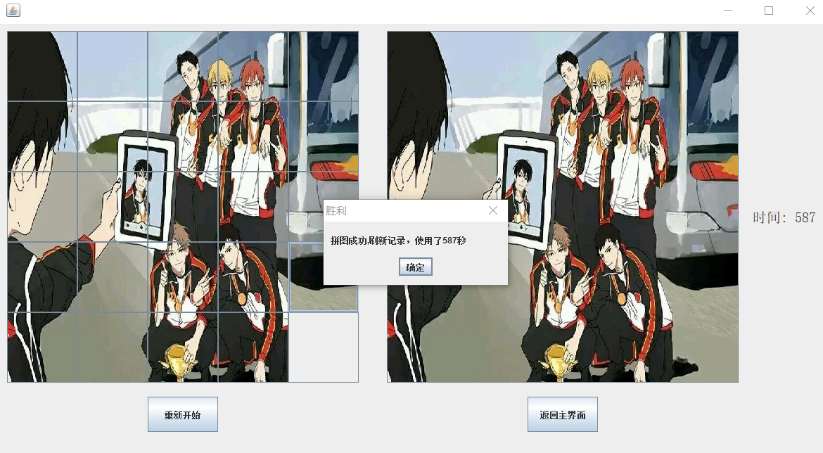

Return to the main interface, click "读取记录", the record has been updated.

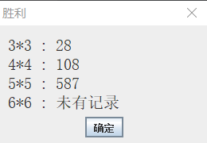

Close all windows.